**DEPARTMENT OF INFORMATION TECHNOLOGY**

**PONDICHERRY ENGINEERING COLLEGE**

**PUDUCHERRY- 605014.**

**(AUTONOMOUS)**

**B.TECH (IT)-VI SEMESTER**

**LAB RECORD FOR**

**IT123- SOFTWARE DEVELOPMENT LABORATORY**

**NAME: YOGESHWARAN T**

**REG NO. : 16IT159**

***SUBMITTED TO***

**PONDICHERRY ENGINEERING COLLEGE**

**PUDUCHERRY**

**MAY 2019**

**DEPARTMENT OF INFORMATION TECHNOLOGY**

**PONDICHERRY ENGINEERING COLLEGE**

**PILLAICHAVADI-PUDUCHERRY-605014**

**Name**  : YOGESHWARAN T

**Reg No.** : 16IT159

**Semester** : VI

**Branch**  : INFORMATION TECHNOLOGY

**Subject**  : IT123-SOFTWARE DEVELOPMENT LABORATORY

**PONDICHERRY ENGINEERING COLLEGE**

PILLAICHAVADY, PUDUCHERRY.

DEPARTMENT OF INFORMATION TECHNOLOGY

**BONAFIDE CERTIFICATE**

*Certified that this is a bonafide record of practical workdone by*

***MR.YOGESHWARAN T*** *of* ***VI*** *Semester* ***B.TECH*** *class of* ***INFORMATION TECHNOLOGY*** *department**in the* ***IT123- SOFTWARE DEVELOPMENT LABORATORY*** *during the year****2018-2019.***

*Head of the Department Staff In-Charge*

*Submitted for the university examination held on __________________*

*External Examiner Internal Examiner*

|  |  |  |  |
| --- | --- | --- | --- |
| **Ex.No** | **Date** | **Title** | **Staff Sign** |
| 1 | 30/01/2019 | ONLINE MOBILE AND COMPUTER ACCESSORIES SHOPPING SYSTEM  (OBJECT-ORIENTED MINI-PROJECT) |  |
| 2 | 09/04/2019 | ONLINE MOBILE AND COMPUTER ACCESSORIES SHOPPING SYSTEM EXTENDED WITH WAY2SMS GATEWAY  (UML MINI PROJECT) |  |

**SOFTWARE REQUIREMENT SPECIFICATION**

**FOR**

**ONLINE MOBILE AND COMPUTER ACCESSORIES SHOPPING SYSTEM**

**(OMCSS)**

**[OBJECT- ORIENTED MINI PROJECT]**

**ONLINE MOBILE AND COMPUTER ACCESSORIES SHOPPING SYSTEM**

**(OMCSS)**

**1.SCOPE**

In existing online mobile and computer accessories systems there is no facility for the multiple small vendors to register for online sales. Our project aims to resolve this issue by listing all nearby vendors to the customers by providing best choice of purchase from multiple vendors based on comparative analysis of the product. This system provides web application based online purchase through automatic location identification

For purchase details adequate invoice mechanism is done on online to the vendors to trace the bill with the date of delivery. The customer will receive the bill after the payment is made.

**2.OBJECTIVE**

The Online mobile and computer accessories shopping system (OMCSS). There is login for both customer and vendors so that the vendors can update or delete the stacks of items they have. There is a shopping cart facilities for customers to shop n items. The customers can able to compare the products according to various prices in shops. There is Gps detecting which provides the location based shops. There is a adequate invoice mechanisms for vendors along with the date of delivery it is communicated to different shops when n number of items are brought. The bill for the customer is generated after the payment is done along with the shop name , price for each item and the total amount through the single payment mode.

**3. LITERATURE SURVEY**

Our project entitled OMCSS aims to provide the shortest path of the nearby mobile and computer accessories shop to the user. This application saves the time and distance travelled by the user. [2] Location based services in the mobile devices provides the information and services related to the user’s physical location. [3]Services it becomes difficult to find a proper service that reflects the individual preference at the proper time. Due to the small screen of the mobile devices and insufficient of the resources, personalized services and convenient user interface might be useful. This proposes a distance and cost based interface with the personalized recommendation system. In order to purchase the new product to the customers, one has to gather the information about the shop in which the customer purchases the product. This increases the loitering of the customer. Some people can also get a wrong information about a particular shop. This is a common problem in the metropolitan cities. [6] Business struggle to combat loitering as the most have limited means to remove the loiters who aren’t asking potential customers for money. Customers might approach a business but be turned off by the appearance or the behaviour of loiterers who are nearby. Traffic to an area may wane as word gets around about the people loitering there. This affects the person physically and mentally. There is a need for reconstruction of the system which eliminates the limitations of the existing software and upgrade in a most efficient manner. The growth of the internet, and the wireless telecommunication technologies have opened new avenues in a potential area of the mobile computing based services. Recommendation of personalized information . [5] location based service has become an attractive trend for success of business. A recommendation system attempts to find the best way to reach the customer’s destination. The location of the user is an important information item that can be associated to the existing user profile in order to provide efficient recommendations. Also, easy of location enabled devices brings a large amount of the location trajectories representing user’s mobile logs. These location trajectories can be used to mine interesting patterns about user and recommend according to them.

There are two interesting properties that motivate the need for location aware recommendation techniques. They are Preference locality and Travel locality. Preference locality suggests users from a spatial region prefer items that are manifestly different than items preferred by users from other, even adjacent regions. When the recommended items are special, users tend to travel a limited distance when visiting these venues.

Customers can easily login to online site and check a number of shops with different provisions while sitting at home or during their travel. The user need not go search for the shop or to gather information of the shop. The system recommends shops according to the request of the user or according to the previous requests to the user. People can search for shops at any time. This saves then time and energy of the user.

The data and the user details are highly protected and the system assures high reliability. [7] Robust Security allows the customers to see or check for the shops but in case of routing, customers should register. The location of the user is not shared at any purpose but the location pattern of the user that used to recommend shops according to their preference.

This gives the opportunity to shop 24 hours. They also can give feedback about the shop or about the service in locating and providing the path. There are three types of the user for this software. General Public, Customers and the administrators. General public can use the system to see the shops and the rating available. But in order to use the application the user should register with their details like name, mobile number and address of the user. Once registered, Customers can use the applications for viewing the shop description and use to reach the shop. They can also give feedback. [5]Administrators can monitor the process and manage the user details in a very secure manner.

**4. PROPOSED OMCSS PROJECT**

The proposed system is computerized automatic list of mobiles with shops available without much strain to the customer. Benefits of location based shopping for the smart phones and the computer accessories, the project is completely secured and to make the user to purchase their desirable mobiles and the computer accessories and avoid the difficulties. The System after careful analysis has been identified to present with the following modules.

High level architecture diagram explains the architecture that would be used for developing a software product. The architecture diagram provides an overview of an entire system, identifying the main components that would be developed for the product and their interfaces.

**Sends msg notify vendors**

**Less threshold**

**tabel**

**Admin stock maintenance**

**Invoice generation**

**List of accessories**

**Mobile varieties**

**Payment**

**Mobile purchase**

**Computer accessories purchase**

**OMCSS**

**Customer**

**Vendor**

**admin**

**FIG 4.1 HIGH LEVEL ARCHITECTURE DIAGRAM FOR OMCSS**

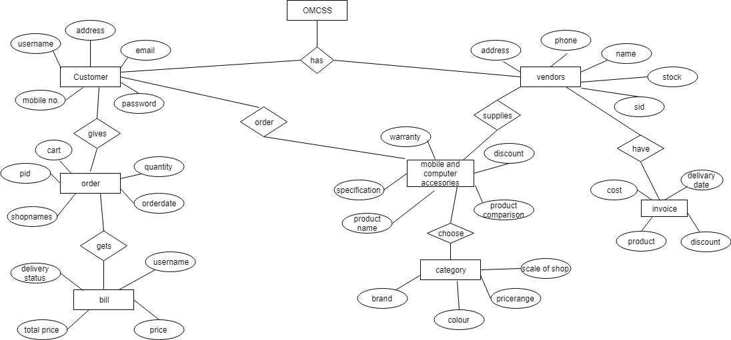

**FIG 4.2 ER DIAGRAM FOR OMCSS**

**5.CONCLUSION**

Technology has made significant progress over the years to provide consumers a better online shopping experience and will continue to do so for years to come.  With the rapid growth of products and brands, people have speculated that online shopping will overtake in-store shopping.  While this has been the case in some areas, there is still demand in market areas where the consumer feels more comfortable seeing and touching the product being bought.  However, the availability of online shopping has produced a more educated consumer that can shop around with relative ease without having to spend a large amount of time.  In exchange, online shopping has opened up doors to many small retailers that would never be in business if they had to incur the high cost of owning store.  At the end, it has been a win-win situation for both consumer and sellers.

**REFERENCES**

**[1]** Anamika S. (2011). Top 10 benefits of online shopping. HubPages. Retrieved (February 14, 2012) from http://anamikas.hubpages.com/hub/Online-shopping-sites-benefits  
  
[2] Associated Press. (2011, November 29). Reports say ‘Cyber Monday’ top online shopping day. New York (AP). Retrieved from http://www.mail.com/business/economy/876350-reports-cyber-monday-top-online-shopping-day.html  
  
 [3]J Doll. (2011, December 28). Drunk online shopping will save this wretched economy. Village Voice. Retrieved (February 14, 2012) from http://blogs.villagevoice.com/runninscared/2011/12/drunk_online_shopping_trend.php  
  
[4] Ehrlich. (2008, July 21). Online Shopping in Today’s Economy. Milstone Insights. Retrieved (February 14, 2012) from http://blog.milestoneinternet.com/education/online-shopping-in-today%E2%80%99s-economy/

[5]Morah, Chizoba. (2011, July 12). Shopping online: Convenience, bargains, and a few scams. Investopedia. http://www.investopedia.com/articles/pf/08/buy-sell-online.asp#ixzz1msc658Sz  
  
[6]This result was confirmed by Grabarczyk, Johnson, Kovach, Kramer, Pleniak (survey, February, 18 2011).  
  
[7]Vespa, M. (2010). Online shopping: Helping or hurting local economy. Central Illinois News Center. Retrieved from http://www.centralillinoisnewscenter.com/home/Online-Shopping--111008209.html  
  
[8]Watershed Publishing. (April 10, 2008). Online Sales to Climb Despite Downbeat Economy, Hit $204B in ’08. Retrieved from http://www.marketingvox.com/online-sales-to-climb-despite-downbeat-econonmy-reach-204b-in-08-037937

**SOFTWARE DESIGN SPECIFICATION**

**FOR**

**ONLINE MOBILE AND COMPUTER ACCESSORIES SHOPPING SYSTEM**

**(OMCSS)**

**[OBJECT-ORIENTED MINI PROJECT]**

**DECOMPOSED OMCSS PROJECT**

The project has been divided into components.

1.Security module

2. Comparative analysis module

3. Bill generation module

**1.SECURITY MODULE**

Login module is used to protect unauthorized member to access this system by providing security by getting username and password from the member. If username and password matches with details in database it will allow user to use the purchase. If the customer forget the password they can reclaim their password using forget password option.

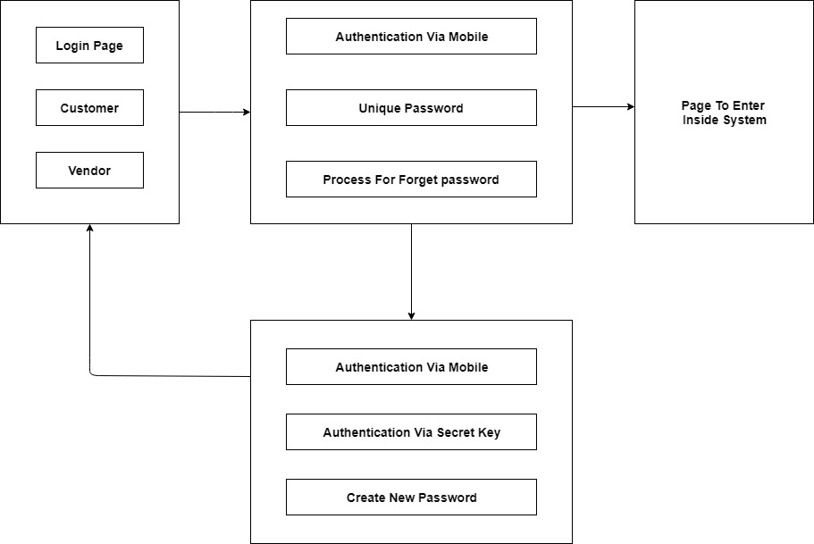

**FIG 1.1 SECURITY MODULE FOR OMCSS PROJECT**

/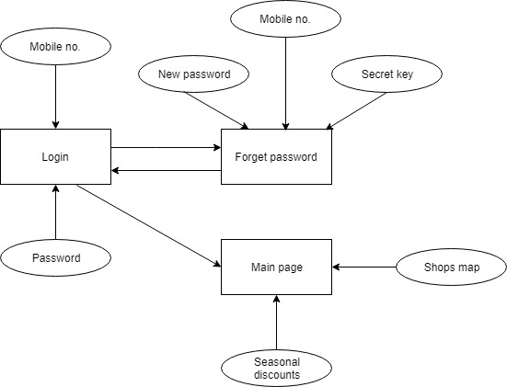

**FIG 1.2 ER DIAGRAM FOR SECURITY MODULE(OMCSS)**

**2.COMPARATIVE ANALYSIS AND SHOPPING MODULE**

This module provides the customer to compare the products with one another depending on the price which they want to buy and it provides the customer to know the specification differences and help to choose the product they want.

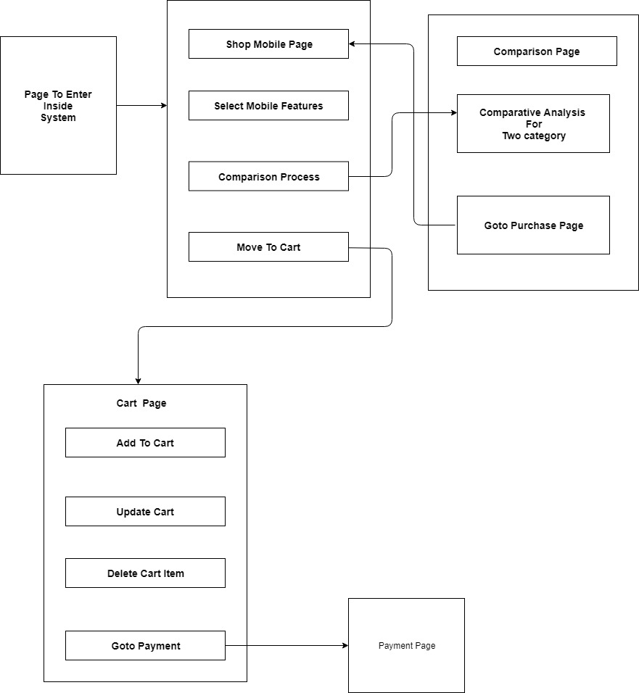

**FIG 2.1 COMPARITIVE ANALYSIS AND SHOPPING MODULE FOR OMCSS**

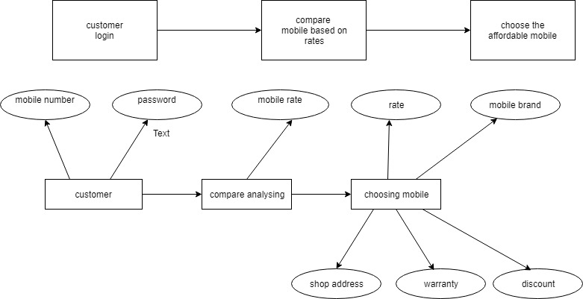

**FIG 2.2 ER DIAGRAM FOR COMPARITIVE ANALYIS AND SHOPPING MODULE(OMCSS)**

**3.BILL GENERATION MODULE**

This module provides the customer to transact the money in a secured manner. This provides the list of various items which is added to cart by customers along with total cost which they can update and then they can pay using their debit or credit cards and after payment they have to enter captcha to generate bill and the pdf is generated for customers.

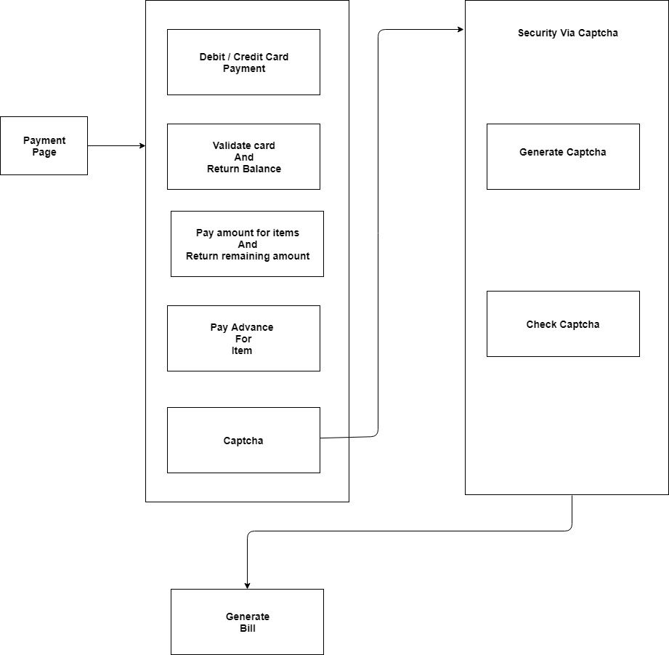

**FIG 3.1 BILL GENERATION FOR OMCSS PROJECT**

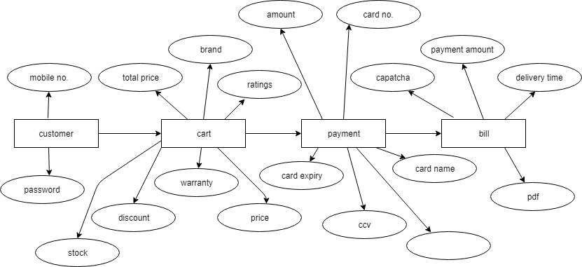

**FIG 3.2 ER DIAGRAM FOR BILL GENERATION MODULE(OMCSS)**

**CONCLUSION**

The design for the OMCSS project is made in such a way that it allows the user to buy the mobiles and computer based on comparison. The project allows the administrator to check the threshold and intimate to vendors.

**CODING**

**FOR**

**ONLINE MOBILE AND COMPUTER ACCESSORIES SHOPPING SYSTEM**

**(OMCSS)**

**PAYMENT PAGE:**

using System;

using MySql.Data.MySqlClient;

using System.Configuration;

using System.Data;

using System.Text;

using System.IO;

using iTextSharp.text;

using iTextSharp.text.pdf;

using iTextSharp.text.html.simpleparser;

using System.Drawing;

namespace WebApplication2

{

public partial class payment : System.Web.UI.Page

{

protected void Page_Load(object sender, EventArgs e)

{

Button1.Visible = false;

Button12.Visible = false;

DataTable dt = new DataTable();

String mycon = "Server = localhost; Uid = root; Database = onlinemobile; Port = 3306; SslMode = none";

String myquery = "SELECT id,name,brand,color,specs,waranty,discount,ratings,price,shop,(price-price*(discount/100)) totalprice FROM cart";

MySqlConnection con = new MySqlConnection(mycon);

MySqlCommand cmd = new MySqlCommand();

cmd.CommandText = myquery;

cmd.Connection = con;

MySqlDataAdapter da = new MySqlDataAdapter();

da.SelectCommand = cmd;

DataSet ds = new DataSet();

da.Fill(dt);

grid1.DataSource = dt;

grid1.DataBind();

con.Close();

grid1.FooterRow.Cells[9].Text = "Total Amount";

grid1.FooterRow.Cells[10].Text = dt.Compute("Sum(totalprice)", "").ToString();

TextBox1.Text = grid1.FooterRow.Cells[10].Text;

}

}

}

**CAPTCHA VERIFICATION:**

protected void Button1_Click(object sender, EventArgs e)

{

string alphabets = "ABCDEFGHIJKLMNOPQRSTUVWXYZ";

string small_alphabets = "abcdefghijklmnopqrstuvwxyz";

string numbers = "1234567890";

string characters = numbers;

if (RadioButtonList1.SelectedItem.Value == "1")

{

characters += alphabets + small_alphabets + numbers;

}

int length = int.Parse(DropDownList1.SelectedItem.Value);

string otp = string.Empty;

for (int i = 0; i < length; i++)

{

string character = string.Empty;

do

{

int index = new Random().Next(0, characters.Length);

character = characters.ToCharArray()[index].ToString();

} while (otp.IndexOf(character) != -1);

otp += character;

}

Label1.Text = otp;

}

}

}

**BILL GENERATION:**

protected void Button3_Click(object sender, EventArgs e)

{

string constr = ConfigurationManager.ConnectionStrings["Dbcs"].ConnectionString;

MySqlConnection con = new MySqlConnection(constr);

try

{

con.Open();

MySqlCommand cmd = new MySqlCommand("select count(*) from `cards` where name ='" + TextBox2.Text + "'and no='" + TextBox3.Text + "'and ccv='" + TextBox4.Text + "'and date='" + TextBox5.Text + "' ", con);

MySqlDataAdapter sda = new MySqlDataAdapter(cmd);

DataTable dt = new DataTable();

sda.Fill(dt);

cmd.ExecuteNonQuery();

if (dt.Rows[0][0].ToString() == "1")

{

string check = "True";

Label11.Text = check;

string str = "select amount from `cards` where no='" + TextBox3.Text + "'";

cmd = new MySqlCommand(str, con);

MySqlDataReader reader = cmd.ExecuteReader();

if (reader.Read())

{

TextBox6.Text = reader["amount"].ToString();

reader.Close();

con.Close();

}

decimal temp = Decimal.Parse(TextBox1.Text);

if (temp >= 10000)

{

TextBox9.Text = "10";

}

if (temp < 10000)

{

TextBox9.Text = "1";

}

}

else

{

string check = "False";

Label11.Text = check;

}

**TESTING**

**FOR**

**ONLINE MOBILE AND COMPUTER ACCESSORIES SHOPPING SYSTEM**

**(OMCSS)**

**SOFTWARE TESTING FOR OMCSS PROJECT**

Software testing is a critical element of software quality assurance and represents the ultimate review of specification, design and coding. Testing is the process of analyzing a software item to detect the difference between existing and required condition (that is defects/error/bugs) and to evaluate the features of the software item. The testing phase involves the testing of system using various test data. Preparation of test data plays a vital role in the system testing. After preparation the test data, the system under study is tested. Those test data, were found and corrected by following testing’s steps and corrections are recorded for future references. Thus a series testing is performed on the system before it is ready for implementation.

The various types of testing on the systems are:

* Unit testing
* Integrated testing
* System testing
* Alpha testing
* Beta testing

**1.UNIT TESTING**

Unit testing is a software verification method used for the testing the smallest testable fragments of an application. Usually this refers to individual function or procedures such as the matching of a product from the research result and the test can only go next unit when the current one is successful. Unit testing allows developers to reorganize code and make sure that all the code is working well. The aim of doing that is not only to confirm the accuracy of the source code but also to improve the source code readability, which make the maintenance in the future easier. In addition, keep doing the regular unit testing can also simplify the integrated testing.

The unit testing is done in our OMCSS project. The module interface is tested to ensure that information properly flows into and out of the program unit under test. The unit testing is done for all module in OMCSS project to check its flow path. The add product module is tested under the unit testing. In this module the admin enters the new product to be added. The module saves the record of the user. The unit testing is done and checked whether the code works correctly.

**2. INTEGRATION TESTING**

Integration testing is used to test an integrated function of an application. As a function is commonly combined by a lot of the individual units, the purpose of the integration testing is in essence to test the communication between each unit. Once there was any problem detected during this process, the source code should be improved up to all the issues had been solved, which is as same as the unit testing. Integrated testing was applied to this project by testing the integration between modules of the main application. In integration testing, all the individual modules are grouped together as an individual code and testing is done for that. In this OMCSS project the modules such as login, view mobiles and search mobiles are grouped together and integration testing is done.

**3. SYSTEM TESTING**

System testing is similar to integration testing, but instead of integrating modules into programs for testing, programs are integrated into systems for testing the interfaces between programs in a system. System testing can be defined in many ways, but a simple definition is that validation succeeds when the software function in a manner that can be reasonably expected by the user.

**4. ALPHA TESTING**

It is virtually impossible for a software developer to foresee how the user will really use a program. Instruction for use may be misinterpreted, strange combination of the data may be regularly used. Output that seemed clear to the tester may be unintelligible to a user in the field. Acceptance testing is also sometimes called alpha testing. Bespoke systems are developed for a single user. The alpha testing proceeds until the system developer and the customer agree that the provided system is an acceptable implementation of the system requirements. Alpha Testing is done for OMCSS project, as a result of this testing the required functionality of the administrator i.e. add mobile, view mobile and update mobile details is added. Thus the alpha testing is completed for OMCSS project.

**5. BETA TESTING**

Security testing checks whenever a software or website is secure or not by checking is it is vulnerable to attacks of anyone can access a database or if anyone can login without authorization. During beta testing a system is delivered among the number of potential users who agree to use it. The customer reports problems to the developers. This provides the product for the real use detects error which may not have been anticipated by the system developers. Several tests cases exist in our OMCSS project to check some of the security that we performed before deployment phase:

* Access bookmarked page without logging into the system.
* Check password strength.
* Restricted pages can’t be accessed by restricted users.

The Beta testing is conducted at one or more end user sites. Unlike alpha testing, the developer generally is not present. Therefore, the beta test is a live application of the Location Based Shopping for the Smart Phones and the Computer accessories software in an environment that cannot be controlled by any other unknown users. A variation on beta testing, called User Acceptance Testing, is sometimes performed when the OMCSS software is delivered to a user under contract.

**REFERENCES**

[1][Dorothy Graham](https://www.google.co.in/search?sa=X&q=Dorothy+Graham&stick=H4sIAAAAAAAAAOPgE-LRT9c3NErKNSpPi89WAvMMjUsyysrMC7VkspOt9JPy87P1y4syS0pS8-LL84uyrRJLSzLyiwBm6CasPAAAAA&ved=0ahUKEwjqg9vl2rHaAhXELI8KHfUuAC0QmxMIjQMoATAR), [Erik P. W. M. Veenendaal](https://www.google.co.in/search?sa=X&q=erik+van+veenendaal&stick=H4sIAAAAAAAAAOPgE-LRT9c3NErKNSpPi89WgvDyKswLzdIytGSyk630k_Lzs_XLizJLSlLz4svzi7KtEktLMvKLAJAc6Og8AAAA&ved=0ahUKEwjqg9vl2rHaAhXELI8KHfUuAC0QmxMIjgMoAjAR), [Rex Black](https://www.google.co.in/search?sa=X&q=Rex+Black&stick=H4sIAAAAAAAAAOPgE-LRT9c3NErKNSpPi89W4tLP1Tcwz85IycrQkslOttJPys_P1i8vyiwpSc2LL88vyrZKLC3JyC8CAN6QvXI6AAAA&ved=0ahUKEwjqg9vl2rHaAhXELI8KHfUuAC0QmxMIjwMoAzAR),” Foundations of Software Testing: ISTQB Certification ”,Cengage Learning Business Press,Third edition,2006.

[2][Srinivasan Desikan](https://www.amazon.in/s/ref=dp_byline_sr_book_1?ie=UTF8&field-author=Srinivasan+Desikan&search-alias=stripbooks) ,”Software Testing: Principles and Practices”,  Pearson India,Second edition,2007

**RESULT SCREENSHOT FOR OMCSS PROJECT**

**1.MAIN PAGE**

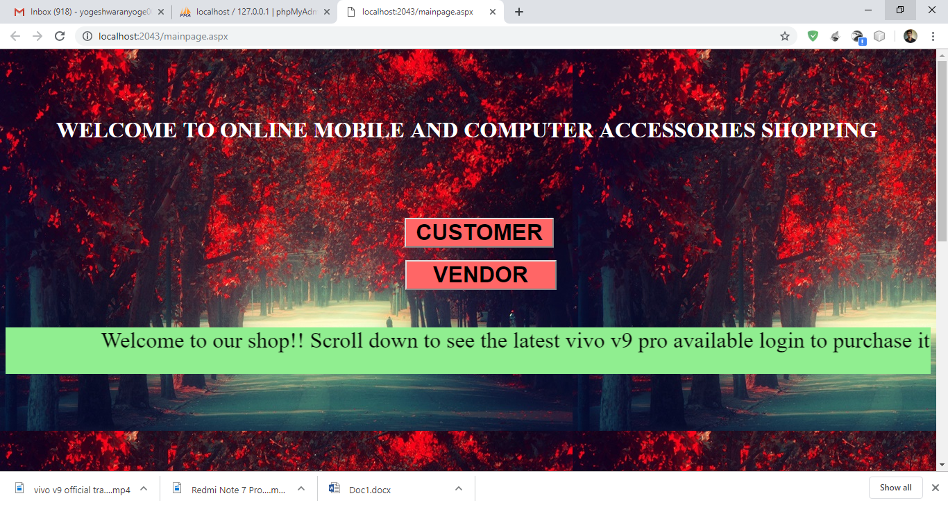

**FIG1.1 MAIN PAGE FOR OMCSS PROJECT**

The above picture is the main page for the website, which act as a gateway for both customers and vendors.

**2.CUSTOMER LOGIN**

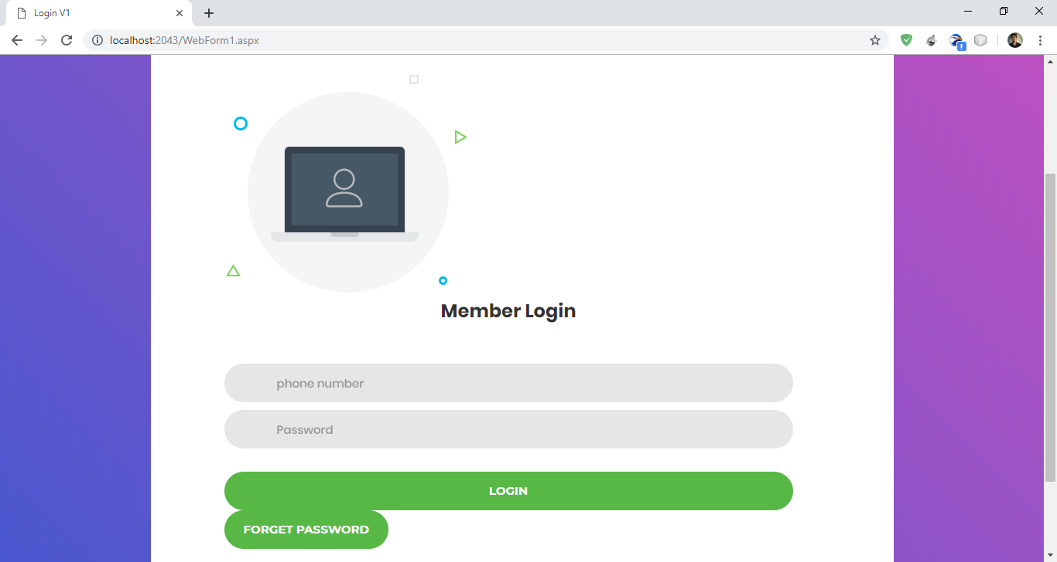

**FIG 2.1 CUSTOMER LOGIN FOR OMCSS PROJECT**

The above screenshot is the login page for the customer where they can login to purchase and if they have forgot their password they can press to forget password option to reclaim their password

**3.FORGET PASSWORD**

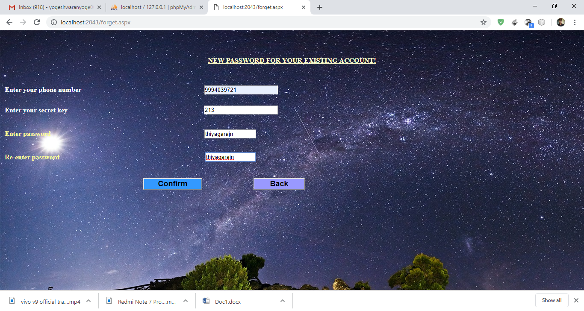

**FIG 3.1 FORGET PASSWORD PAGE FOR OMCSS PROJECT**

The above mentioned figure is forget password where the customer can update their password with the secret key which they provide when they register.

**4.CUSTOMER REGISTRATION**

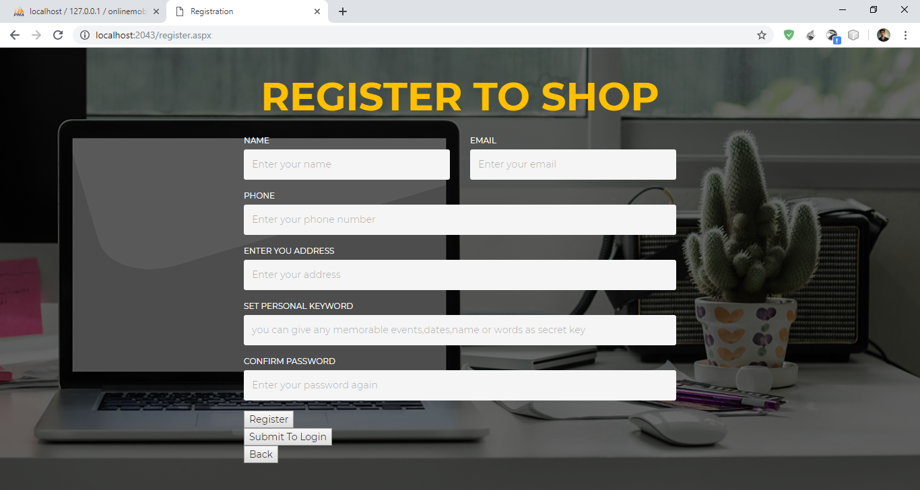

**FIG 4.1 CUSTOMER REGISTRATION PAGE FOR OMCSS PROJECT**

The above mentioned figure is the registration for customer where the required details of customer is collected in order to provide a delivery correctly.

**5.HOME PAGE**

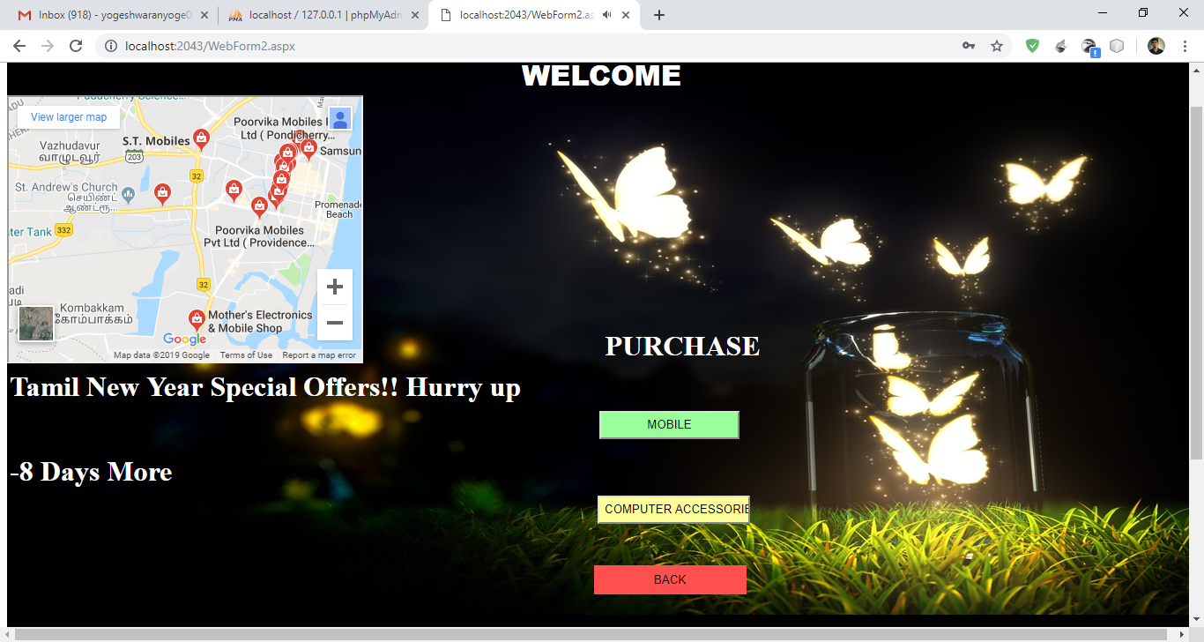

**FIG 5.1 HOME PAGE FOR OMCSS PROJECT**

This above mentioned figure is the home page which represents the different options to choose what the customer want to buy and a locality map is provided to show the near by shops.

**6.COMPUTER ACCESSORIES PURCHASE:**

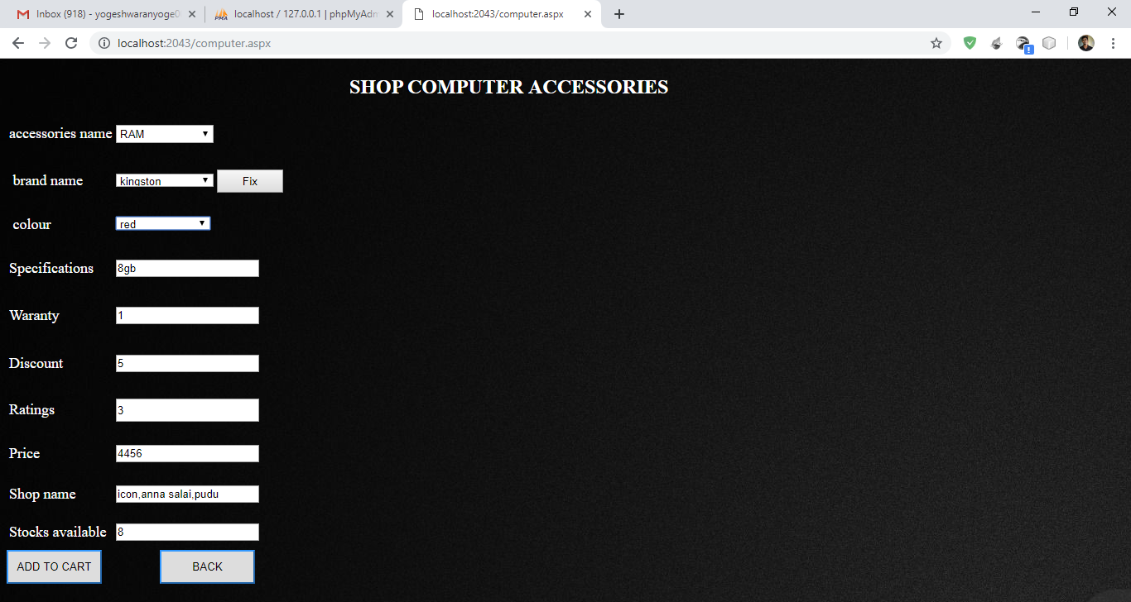

**FIG 6.1 COMPUTER ACCESSORIES PURCHASE PAGE FOR OMCSS PROJECT**

**7.MOBILE PURCHASE**

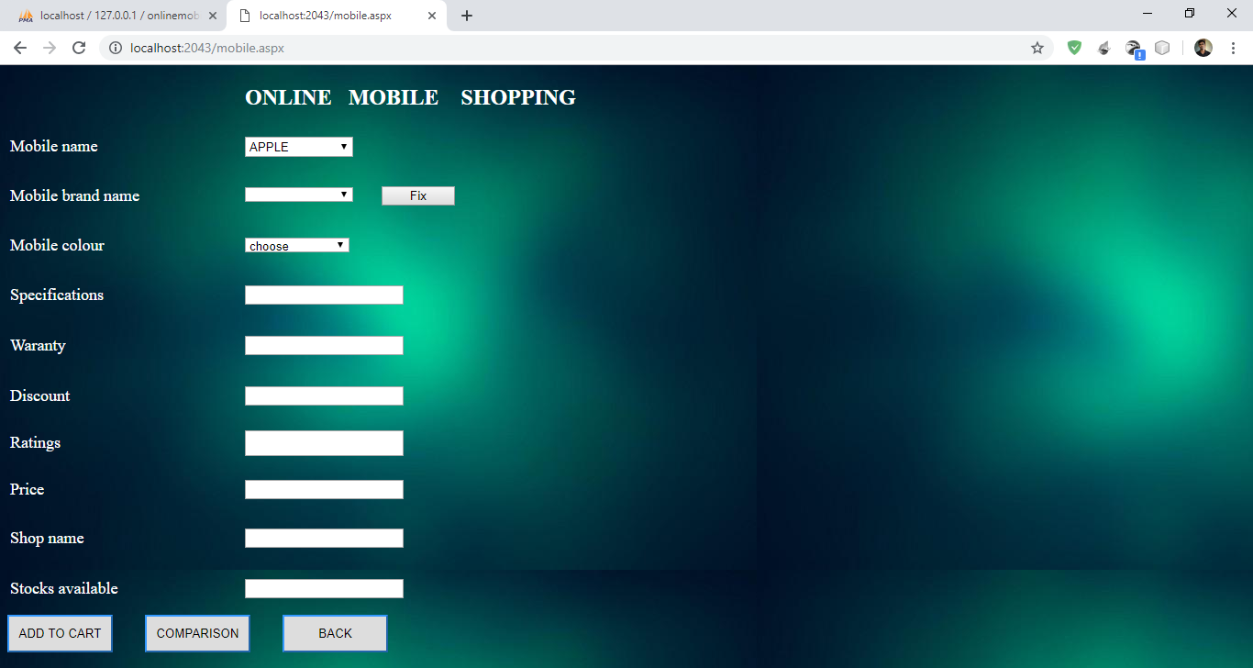

**FIG 7.1 MOBILE PURCHASE PAGE FOR OMCSS PROJECT**

The above mentioned figure is the mobile purchasing portal where the customer can choose the item which they wanted to buy.

**8.MOBILE COMPARISON PAGE**

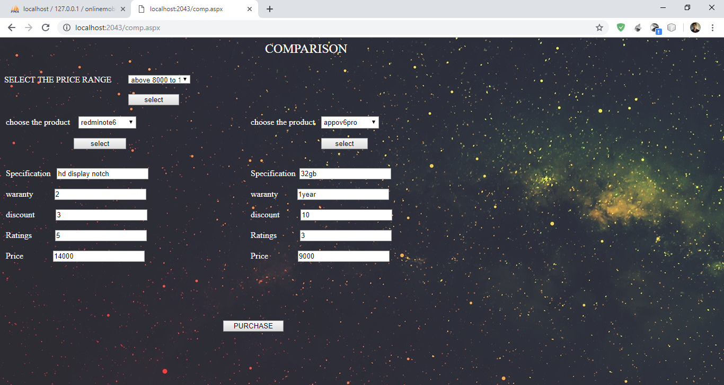

**FIG 8.1 MOBILE COMPARISON PAGE FOR OMCSS PROJECT**

The above mentioned webpage where the customer can compare the mobiles with one another depending upon price and can purchase of their choice.

**9.SHOPPING CART**

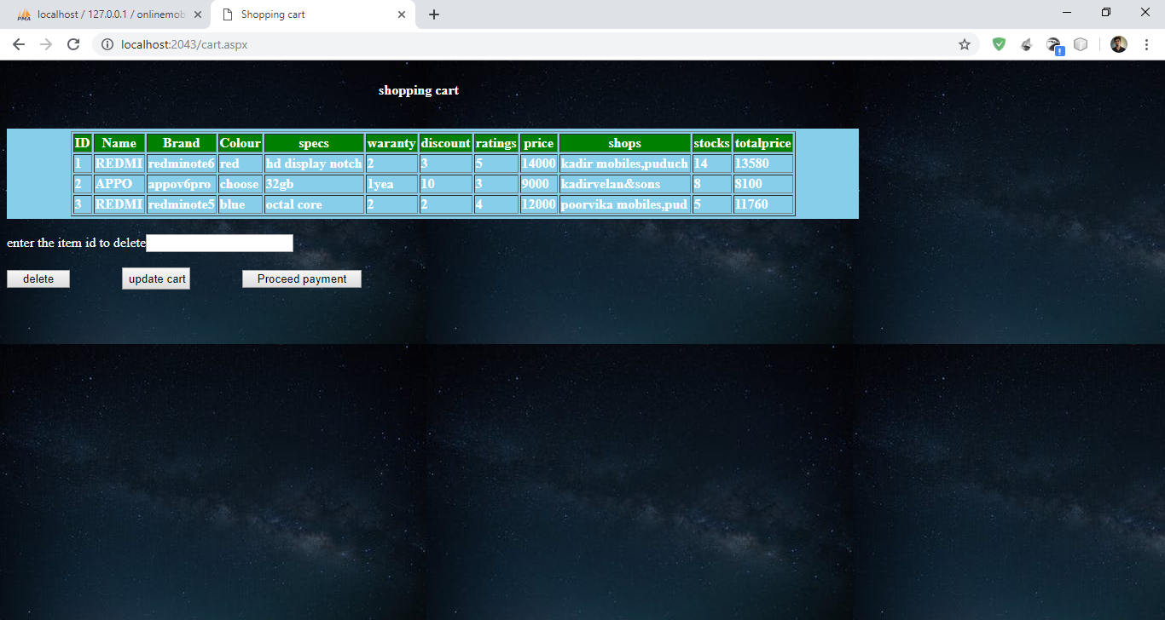

**FIG 9.1 SHOPPING CART PAGE FOR OMCSS PROJECT**

The above mentioned page is the cart where the items which have been selected by customer is added and in card customer can update and delete items of their choice.

**10.PAYMENT PAGE**

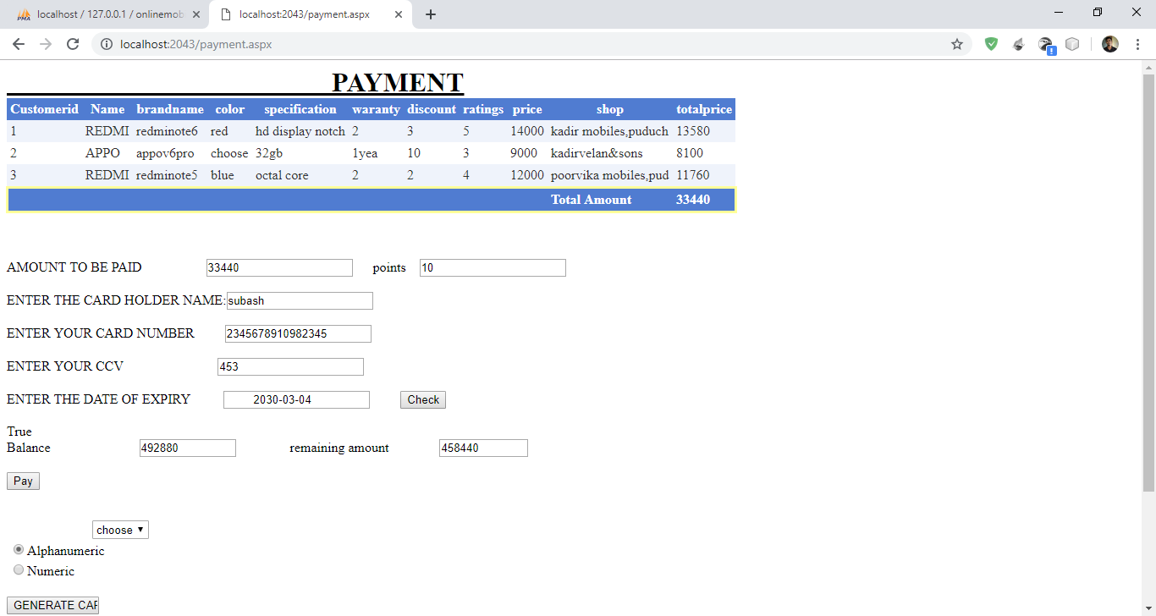

**FIG 10.1 PAYMENT PAGE FOR OMCSS PROJECT**

The above page is for payment the customer will be given the amount to be paid based on the discount.

And they can make their payment on giving their card number where after payment they balance is returned.

**11.BILL GENERATION**

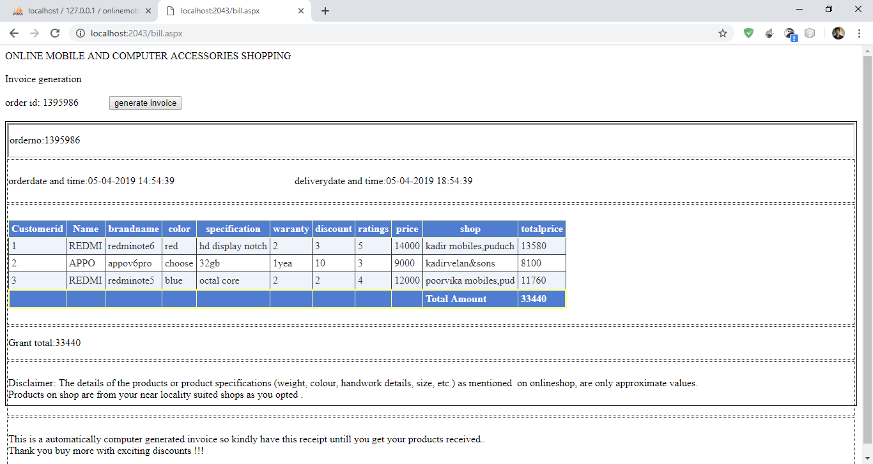

**FIG 11.1 BILL GENERATION PAGE FOR OMCSS PROJECT**

The above mentioned webpage is for bill generation is done after the payment is done and the customer can download the copy as pdf and they can retain it includes delivery details also.

**12.VENDOR LOGIN**

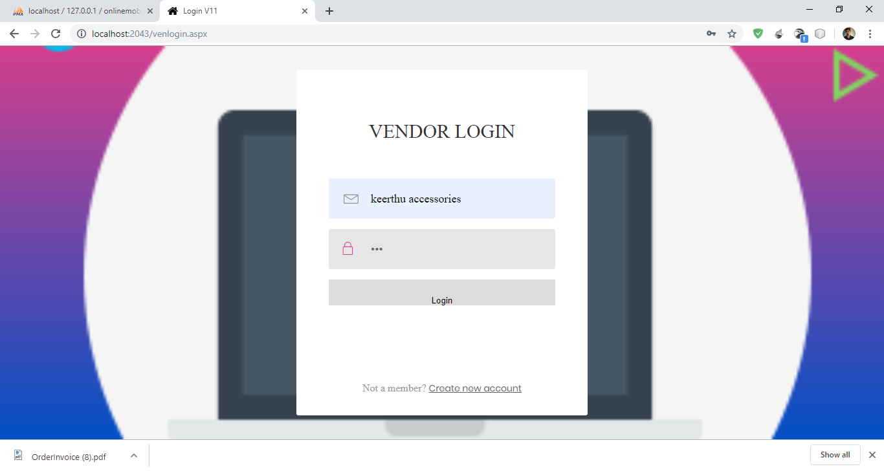

**FIG 12.1 VENDOR LOGIN PAGE FOR OMCSS PROJECT**

The above mentioned webpage is the vendor login where the vendor can register their shop which provides a security for the whole website that only authorized vendor can only access their shop details.

**13.VENDOR REGISTRATION**

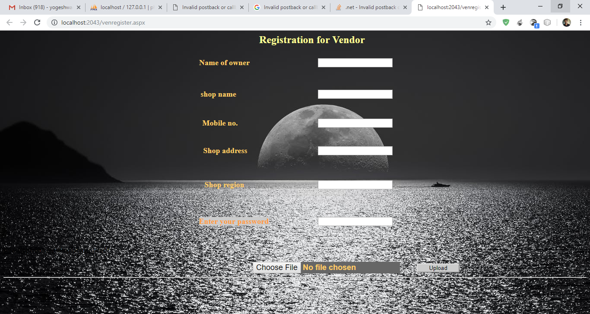

**FIG 13.1 VENDOR REGISTRATION PAGE FOR OMCSS PROJECT**

The above mentioned webpage is for vendor registration where the vendor can register their shop with required details and he can submit his shop license to avoid fraud in online.

**14.VENDOR HOME PAGE**

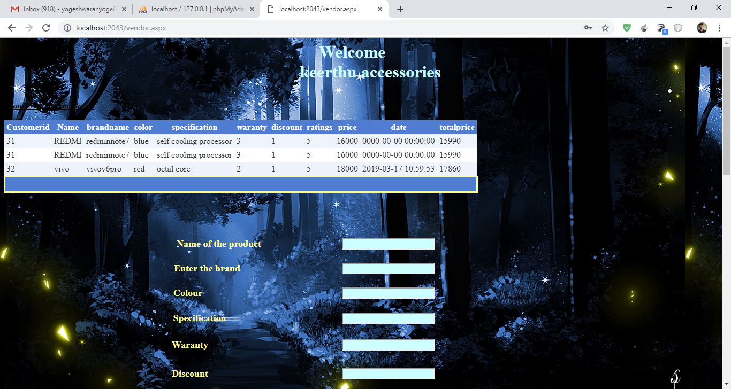

**FIG 14.1 VENDOR HOME PAGE FOR OMCSS PROJECT**

The above mentioned screenshot is for the vendor home page where he can see the details of items ordered along with time and place and then he can update the stock

**15.STOCK UPDATION**

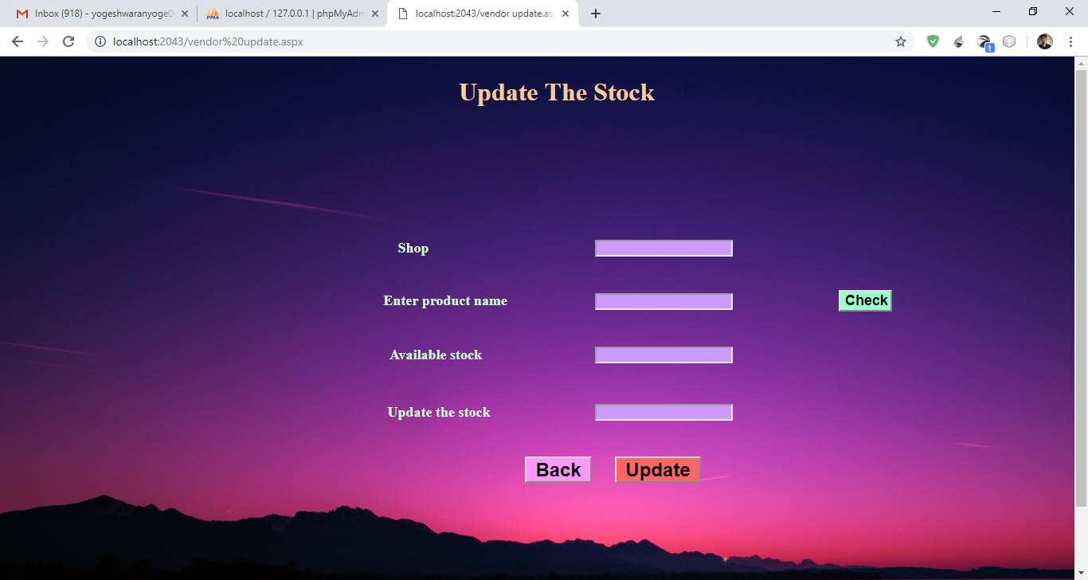

**FIG 15.1 STOCK UPDATION PAGE FOR OMCSS PROJECT**

The above mentioned webpage is to provide updating of stock for already existing item for the vendor .

**16.ADMIN PAGE**

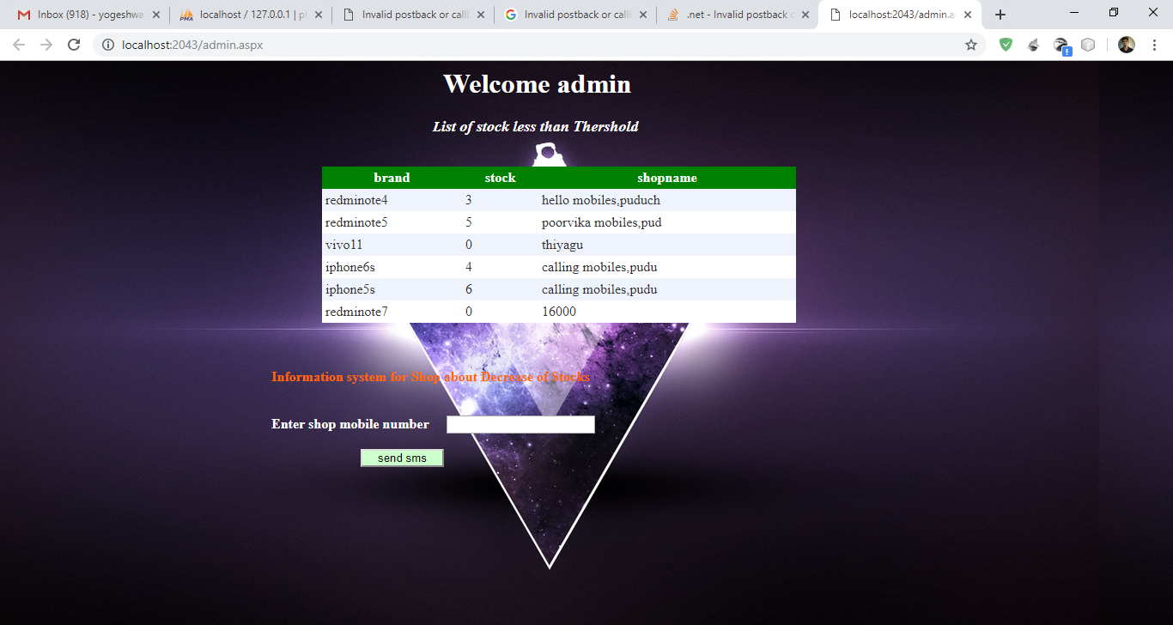

**FIG 16.1 ADMIN PAGE FOR OMCSS PROJECT**

The above mentioned webpage is for the admin where the admin receives the items which is less of the stock threshold and admin can inform the vendor regarding the stock to update through sms gateway.

**CONCLUSION**

This OMCSS project solves the problem occurs due to the location and it provides the customers to get their product for the nearby vendors, it paves the way for both the customers and the vendors in a beneficial way. The customer can get the product in a quick manner and if any clarification is there it is easy for them to solve it and this system makes the small vendors to get benefited by the common admin. More over there is a comparison features which enables the customers to select the product according to their wish.

**FUTURE ENHANCEMENT**

There are also few features which can be integrated with this system to make it more flexible. More advance software for the location based shopping including more facilities can be added. Platforms can be hosted on online servers to make it accessible worldwide. The facility of the customers to pay for their products through the card to some extend of the money.

**ENTENSION OF ONLINE MOBILE AND COMPUTER ACCESSORIES SHOPPING SYSTEM**

**(UML)**

**ONLINE MOBILE AND COMPUTER ACCESSORIES SHOPPING SYSTEM EXTENDED WITH WAY2SMS GATEWAY**

**(UML MINI PROJECT)**

**1.MODULE DECOMPOSITION**

In the proposed system there are three modules. They are

* Security module
* Comparative analysis and Shopping module
* Bill generation module

**SECURITY MODULE:**

In this there will login for the customers and the vendors in that they can login using the phone number and the unique password. On authentication they are made to access the website. By forget password the user can enter their secret key and they can change password.

vendor

customer

**FIG 1.1 USE CASE DIAGRAM FOR SECURITY MODULE OMCSS**

**COMPARATIVE ANALYSIS AND SHOPPING MODULE**

In this the customer can able to compare the various products based on price, specification and near by shops. The customer after satisfaction by comparative analysis they enter into the purchase many items as there is a cart and the total for all items in cart can be deleted or updated.

vendor

customer

**FIG 1.2 COMPARATIVE ANALYSIS AND SHOPPING MODULE OF OMCSS**

**BILL GENERATION MODULE**

In this the customer can pay the bill online by using the debit or the credit card they can also pay advance for that product and on delivery the remaining amount shall be paid, the customer is made the safe pay using the captcha.

**FIG 1.3 BILL GENERATION MODULE OF OMCSS**

* **UML EXTENSION OF WAY2SMS GATEWAY OF OMCSS**

In this proposed OMCSS project an UML extension is made by providing sms notification via way2sms gateway. The admin maintenance the vendor and customer relationship. Admin fixes the threshold for the stocks which are present when the number of purchase is more for an item then the threshold will be higher than the normal item, since the demand is high. the customer are allowed to pay advance option, they can pay the advance of their choice to purchase an item and later on delivery of the item they can pay the remaining total items. The vendor who have registered for the online website have to submit their shop license for admin verification so that the fraud is reduced.

**customer**

**admin**

**vendor**

**FIG 1.4 USE CASE DIAGRAM FOR EXTENSION OF OMCSS**

**OUTPUT**

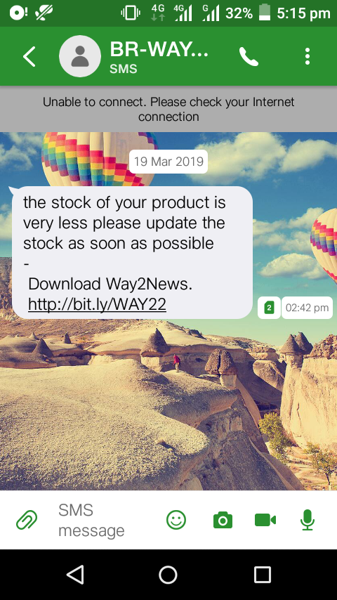

**FIGURE 1.5 SNAPSHOT OF SMS FOR THRESHOLD FOR OMCSS**

**CONCLUSION**

The UMLproject of OMCSS aids in intimation of notifications to vendors regarding the products threshold so the vendors can login and update the stock for purchase of customer.

This project can be enhanced by increasing the features for customer to track the order which they placed.